**Cabillos John Antony P**

**Scores in Quiz**

**Navigation unit: 3**

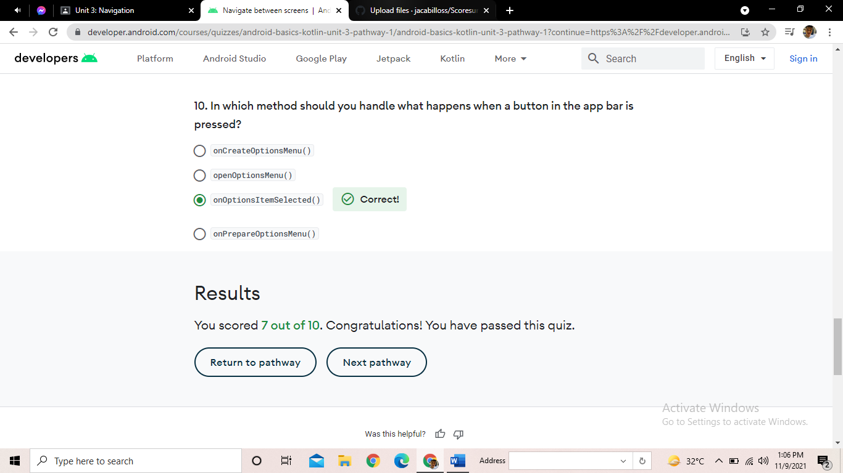Pathway 1

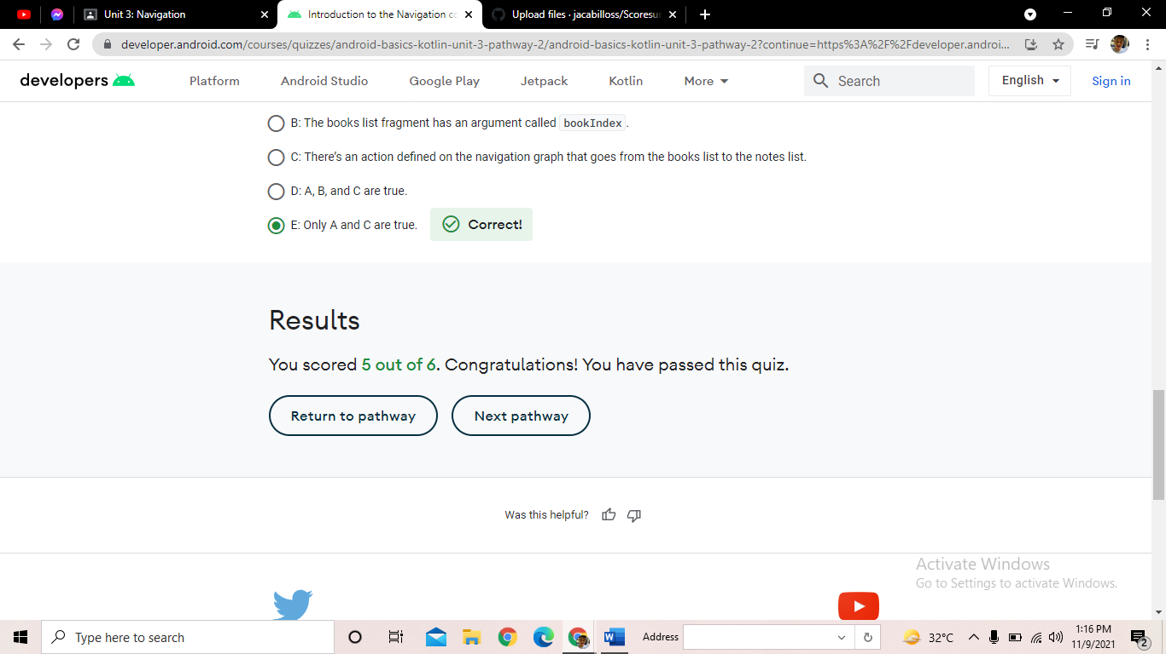Pathway 2

Pathway 3

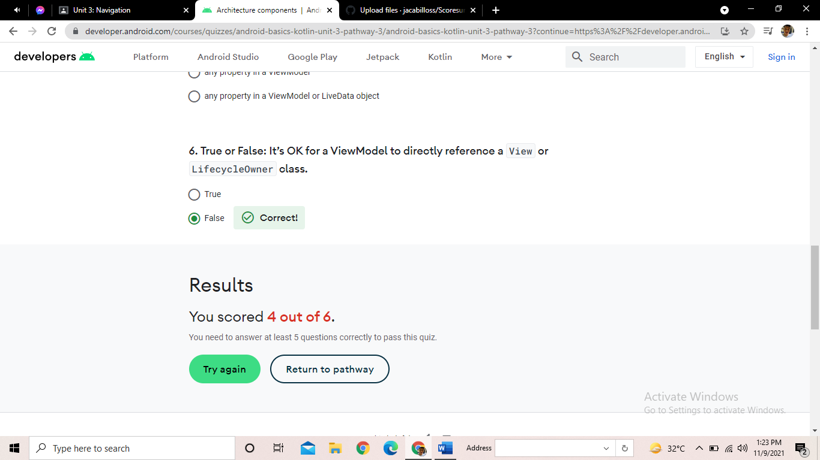

Pathway 4

